DEVELOP A MOBILE APPLICATION

|  |  |
| --- | --- |
| Team ID | PNT2022TMID17579 |
| Project Name | IoT-Enabled Smart Farming Application |

MIT APPLICATION:

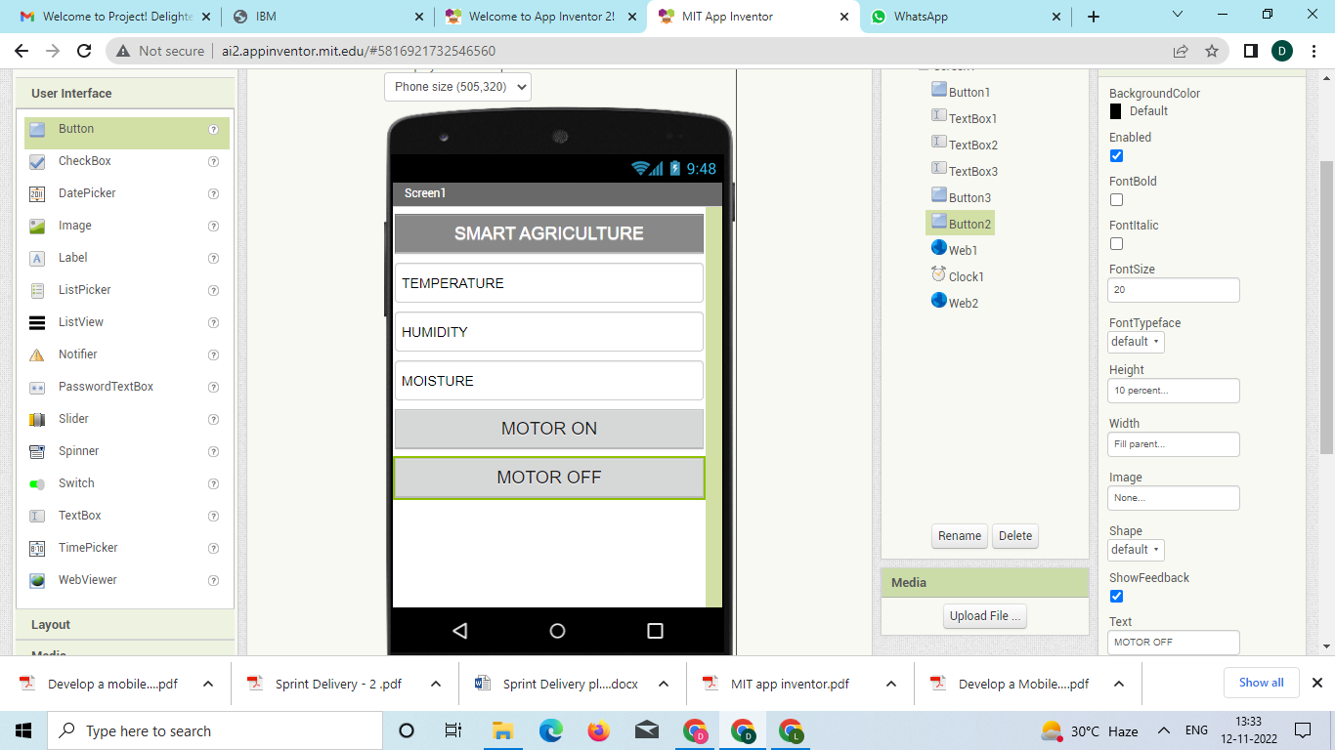

RESULT:

